Experiment – 11

**Aim: Interfacing Bluetooth Module (HC-05) with Arduino Uno.**

# Components

* Arduino Uno R3
* Small Breadboard
* Jumper cable
* Bluetooth module (HC-05)

# Theory

1. **Arduino Uno R3**

An open-source microcontroller board used to control electronic components and execute programmed instructions.

1. **Small Breadboard**

A compact, reusable board for prototyping circuits without soldering, allowing easy component connections.

1. **Jumper Cable**

Flexible wires used to establish electrical connections between components on a breadboard or to an Arduino.

1. **Bluetooth Module (HC-05)**

A serial communication module that enables wireless data exchange between the Arduino and Bluetooth-enabled devices.

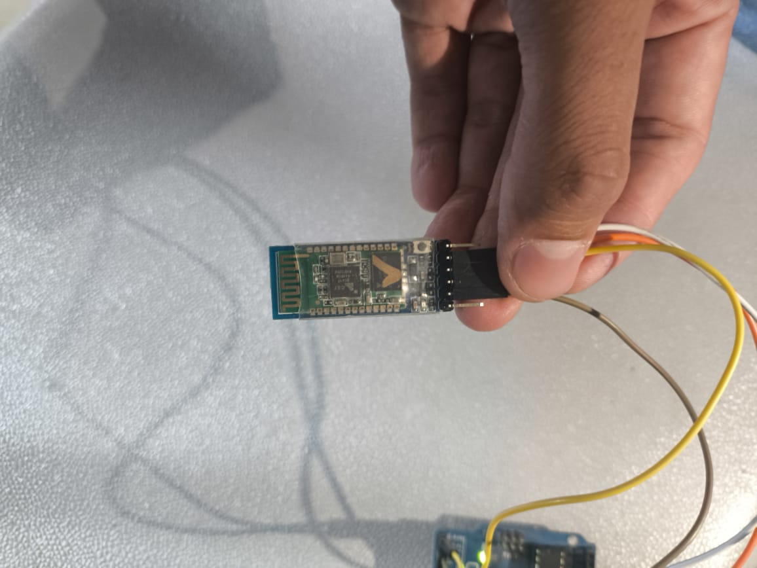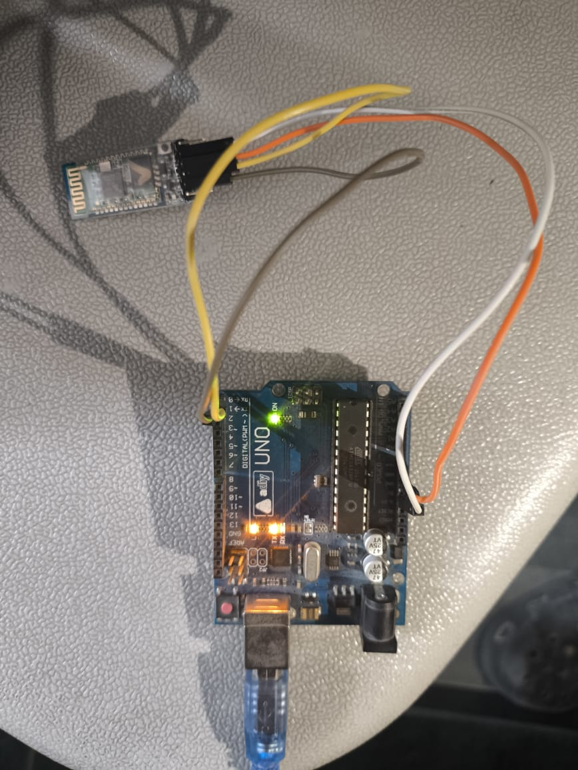**Circuit Design**

Procedure to Design a Bluetooth Controlled LED Circuit using Arduino on Tinkercad

1. Add Components to the Workspace

Add an Arduino Uno R3 to the workspace.

Place a small breadboard next to the Arduino.

Add an LED to the breadboard.

Position a Bluetooth module (HC-05) on the breadboard.

Use jumper cables to establish proper connections between the components.

1. Build the Circuit Connections

Power Supply Connections:

Connect the 5V pin of the Arduino to the VCC pin of the Bluetooth module.

Connect the GND pin of the Arduino to the GND pin of the Bluetooth module and the negative rail of the breadboard.

Bluetooth Module Connections:

Connect the TX pin of the Bluetooth module to pin 0 (RX) of Arduino.

Connect the RX pin of the Bluetooth module to pin 1 (TX) of Arduino.

LED Connections:

Connect the anode of the LED to pin 13 of the Arduino with a resistor.

Connect the cathode of the LED to the negative rail (GND) of the breadboard.

1. Code

char inputByte;

void setup() {

Serial.begin(9600);

pinMode(13, OUTPUT);

}

void loop() {

if (Serial.available() > 0) {

inputByte = Serial.read();

Serial.println(inputByte);

if (inputByte == 'R') {

digitalWrite(13, HIGH);

} else if (inputByte == 'r') {

digitalWrite(13, LOW);

}

}

}

1. Simulate the Circuit

Click "Start Simulation" in Tinkercad.

Use a Bluetooth terminal app on your phone to send data.

Send 'R' to turn ON the LED and 'r' to turn it OFF.

**Conclusion**

This experiment demonstrates how to wirelessly control an LED using Bluetooth communication between a smartphone and Arduino via the HC-05 module.